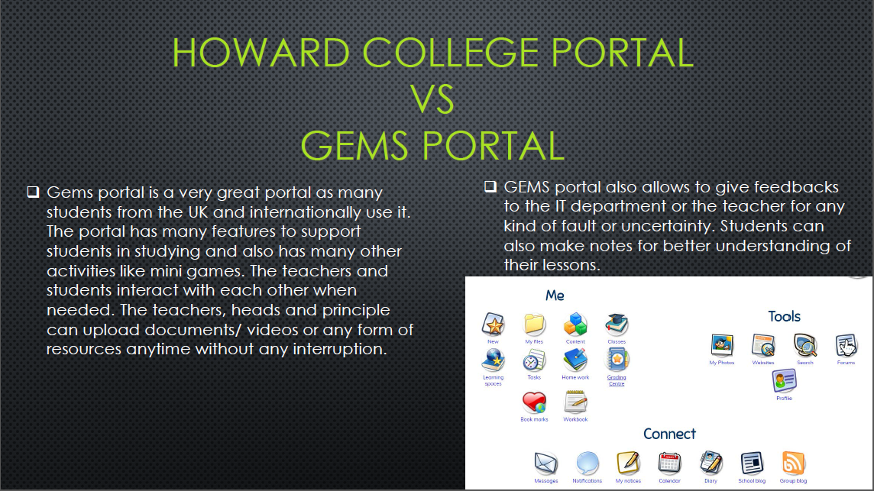

Here I mentioned some of the features of another educational organisations’ portal, which should be in the information system of the Howard College with a screen shot.

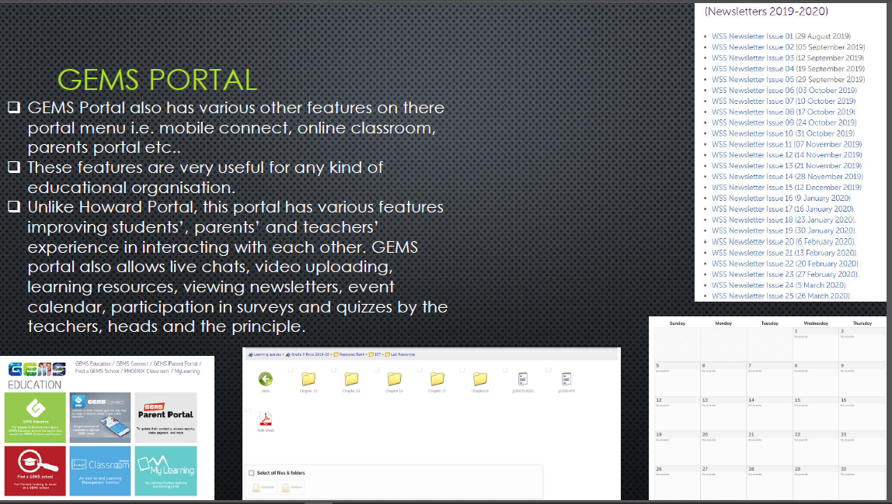

Here I am comparing both of their portals and mentioning all the services, which are essential for the current information system for Howard College. Again attaching some screen shots.

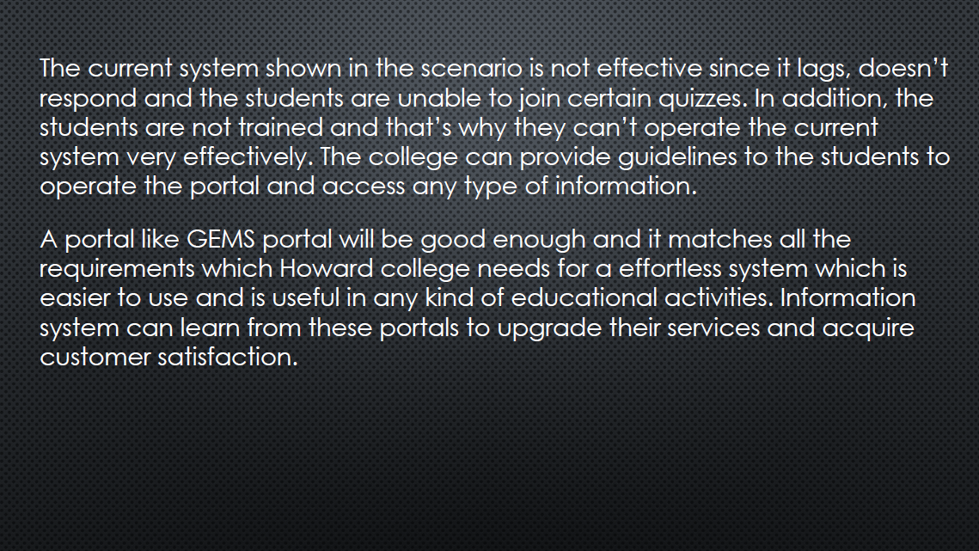

Here I wrote the effectiveness of the current system. Answering 1 B

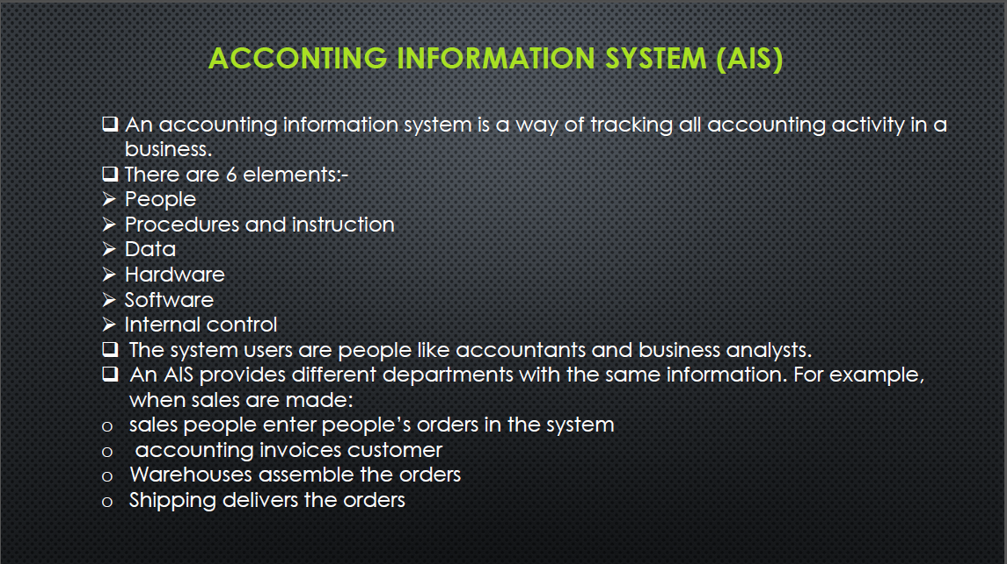

According to question 1 C, I chose accounting and wrote the meaning with 6 elements followed by the steps of accounting information system